SIMATS ENGINEERING
Department of Computer Science & Engineering
ASSESSMENT TOOL 1- EXPERIMENTS

Course Code: | CSA1209 & CSA1215 |  |  | Course Title: | Computer Architecture
CO Assessed: | CO3 |  |  | Assessment: | ASSESSMENT TOOL 1- EXPERIMENTS
Weightage: | 40% |  |  | Total Marks: | 25
CO3 Statement: |  | Design processor organization by constructing pipelined datapath structures, identifying hazard types (data, control, structural), and comparing superscalar techniques such as out-of-order execution, speculative execution, and simultaneous multithreading (SMT). (BL6)
Student Name: | Jasim Asmaan A |  |  | Reg.No.: | 192421060
Department: | B.Tech IT |  |  | Date:

ANNEXURE A

- Design and simulate a system that performs register transfer operations along with basic arithmetic and logic operations such as addition, subtraction, AND, and OR. Use multiple registers to demonstrate how data is transferred between them during execution, and analyze the sequence of operations and the role of the ALU in processing data.
- Create a model of a computer system using single-bus and multi-bus organization, and perform data transfer operations between registers, memory, and I/O. Compare the time taken and efficiency of both approaches, and analyze how multiple bus structures improve parallel data transfer and reduce bottlenecks.
- Simulate a 5-stage instruction pipeline (Fetch, Decode, Execute, Memory, Write-back) and execute a set of instructions. Measure the performance in terms of speedup and throughput, and compare it with a non-pipelined system to evaluate the effectiveness of pipelining.
- Develop a pipeline execution scenario where data hazards, control hazards, and structural hazards occur. Observe their impact on instruction execution, and implement techniques such as stalling, data forwarding, and branch prediction to resolve these hazards and improve performance.
- Analyze a processor supporting superscalar execution, including out-of-order and speculative execution, and extend the study to include hyper-threading and simultaneous multithreading (SMT). Evaluate how multiple instructions are executed in parallel and compare the performance improvements in terms of instruction throughput and resource utilization.

Code of Conduct:

I Jasim Asmaan A (Name / Reg No) certify that this submission is my original work and that I have adhered to the guidelines specified for this assessment.I understand that any violation of academic integrity rules will result in disciplinary action.

Signature of the student:

MARKS ALLOCATION
 | Understanding of Concepts (20%) | Experimental Design (20%) | Use of Tools (25%) | Analysis of Results (20%) | Documentation (15%)
Q1
Q2
Q3
Q4
Q5

RUBRICS FOR CALCULATION:

Criteria | Weightage | Level 4 – Exemplary | Level 3 – Proficient | Level 2 – Developing | Level 1 – Beginning
Understanding of Concepts | 25 | Demonstrates thorough understanding and effectively integrates multiple concepts/technologies | Good understanding with proper integration of most concepts | Basic understanding; limited or partial integration | Poor understanding; unable to integrate concepts
Experimental Design | 30 | Well-planned, systematic implementation with optimal solution | Correct implementation with minor issues | Basic implementation with errors or inefficiencies | Incorrect or incomplete implementation
Use of Tools | 20 | Effective and advanced use of tools/technologies with proper configuration | Appropriate use of tools with correct execution | Limited or inconsistent use of tools | Incorrect or minimal use of tools
Analysis of Results | 15 | Insightful analysis with accurate interpretation and validation of results | Good analysis with reasonable interpretation | Basic analysis with limited insights | Poor or incorrect analysis of results
Documentation | 10 | Clear, well-structured documentation with diagrams, code, and results | Organized documentation with necessary details | Basic documentation with missing details | Poor or incomplete documentation

1.
1. Register Transfer Operations and ALU:

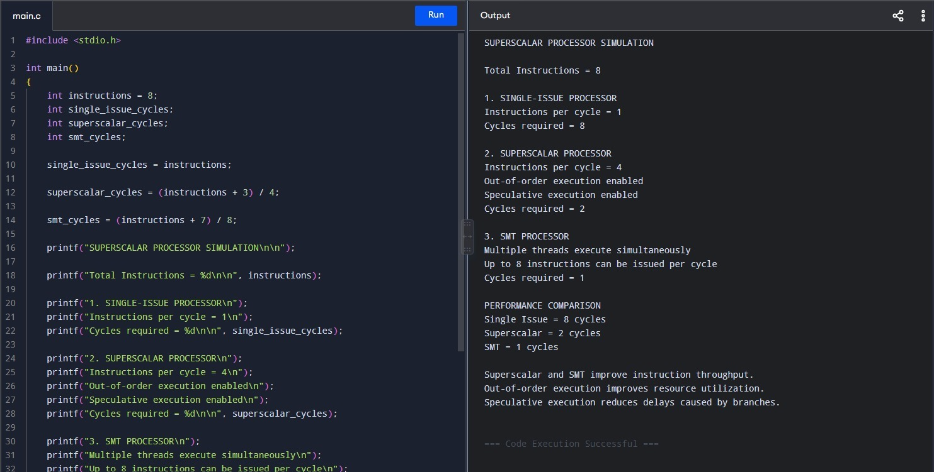
2. Single-Bus and Multi-Bus Organization:

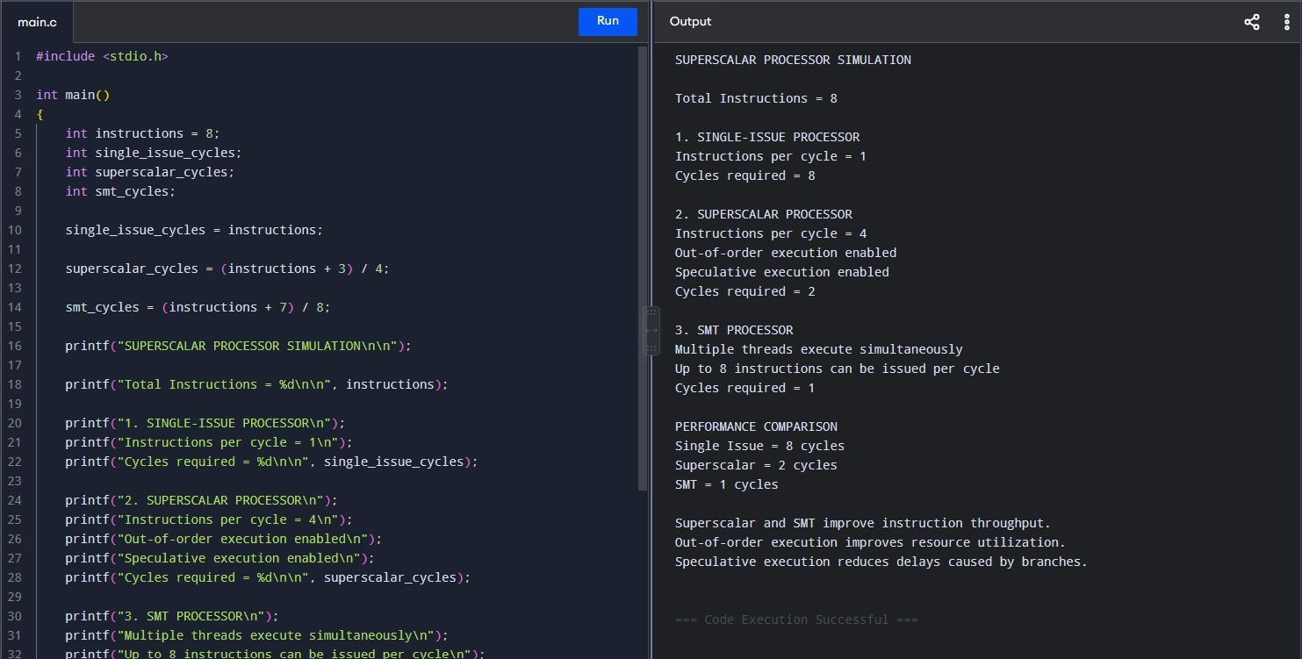

3. Five-Stage Instruction Pipeline
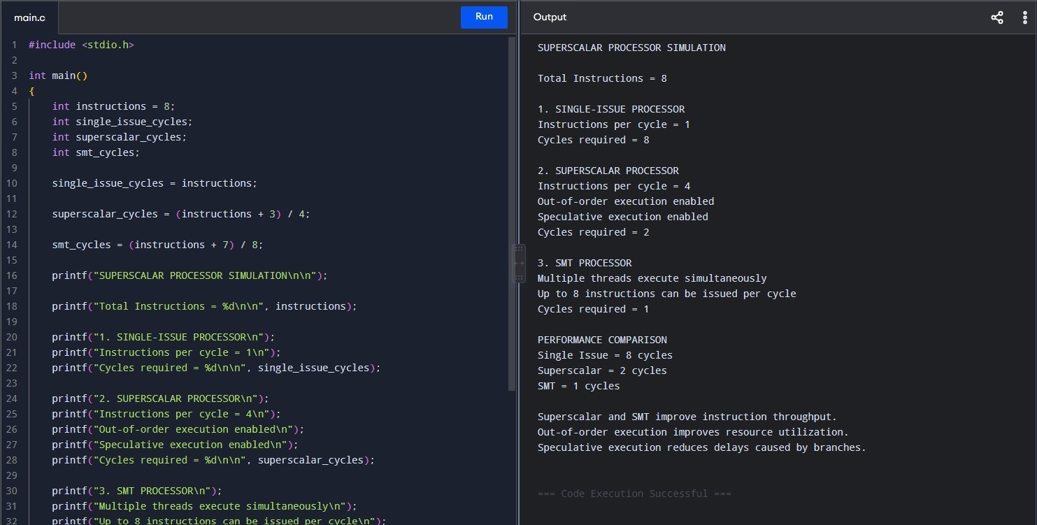

4. Without Pipelining
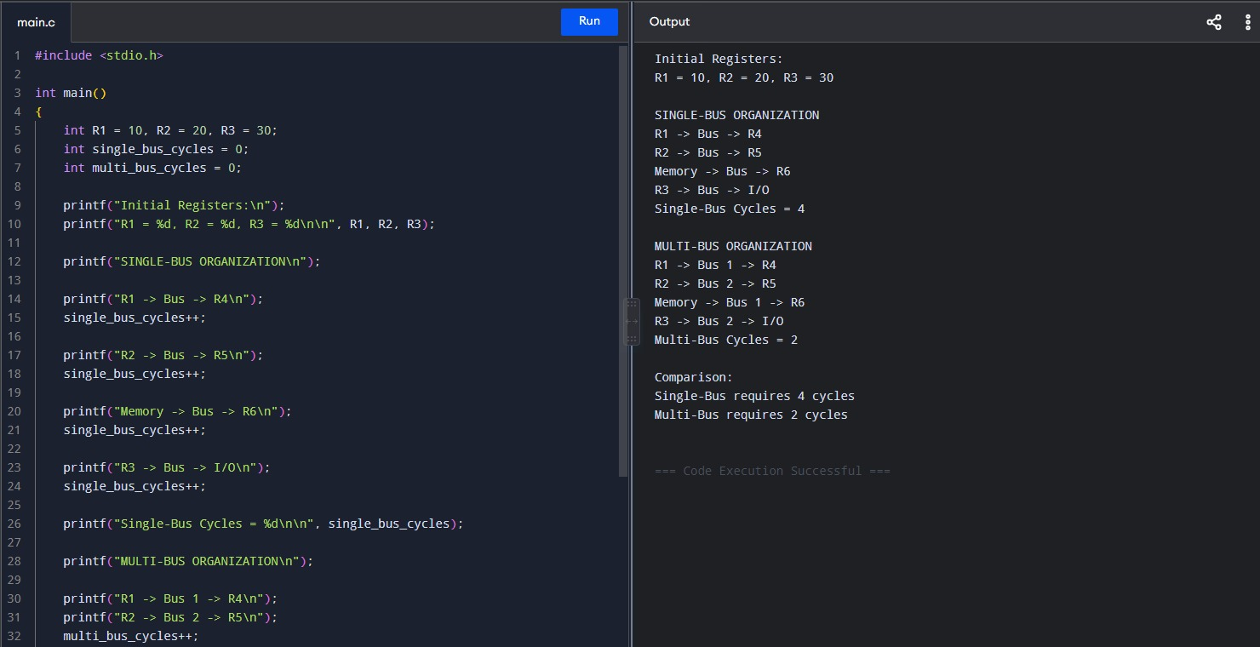

5. Superscalar Execution, Out-of-Order Execution, Speculative Execution and SMT
